**Doubt & Unbelief**

# **What is Doubt?**

* Doubt means to hesitate, to contend, to differ, to stagger, to waver
* Doubt is not always bad
  + If you don’t know something, you will have some doubts
    - Doubt is when you just don’t know
  + But if you choose to doubt by looking at the wind and the waves…
* Doubt feeds on ignorance – the cure is the knowledge of the truth – you shall know the truth and the truth shall set you free
* Doubt is a common temptation among believers and can be described as wavering between two minds or lacking confidence in God.

# **Examples of reasonable doubt**

#### **The leper believe that Jesus could heal him – but honestly didn’t know if Jesus would heal him – but as soon as Jesus solved his doubt, he believed**

Matthew 14:31

**2**And, behold, there came a leper and worshipped him, saying, Lord, if thou wilt, thou canst make me clean.

**3**And Jesus put forth his hand, and touched him, saying, I will; be thou clean. And immediately his leprosy was cleansed.

# **Examples of unreasonable doubt**

#### **Peter stopped believing and started doubting because he believed more in the power of the wind and the waves, than in the word when Jesus said come.**

##### Matthew 8:2

31 And immediately Jesus stretched forth his hand, and caught him, and said unto him, O thou of little faith, wherefore didst thou doubt?

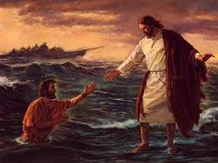

# **What is Unbelief?**

##### **Unbelief means to separate thoroughly, withdraw from, to oppose**

##### **Unbelief is when you know, but you have decided not to believe**

###### Except I shall see in his hands the print of the nails, and put my finger into the print of the nails, and thrust my hand into his side, I will not believe.

###### Thank God 1for mercy and grace because this is unbelief at its maximum!

##### [John 20:24-29](https://www.biblegateway.com/passage/?search=John%2020%3A24-29&version=NIV)

**24**But Thomas, one of the twelve, called Didymus, was not with them when Jesus came.

**25**The other disciples therefore said unto him, We have seen the Lord. But he said unto them, Except I shall see in his hands the print of the nails, and put my finger into the print of the nails, and thrust my hand into his side, I will not believe.

**26**And after eight days again his disciples were within, and Thomas with them: then came Jesus, the doors being shut, and stood in the midst, and said, Peace be unto you.

**27**Then saith he to Thomas, Reach hither thy finger, and behold my hands; and reach hither thy hand, and thrust it into my side: and be not faithless, but believing.

**28**And Thomas answered and said unto him, My Lord and my God.

**29**Jesus saith unto him, Thomas, because thou hast seen me, thou hast believed: blessed are they that have not seen, and yet have believed.

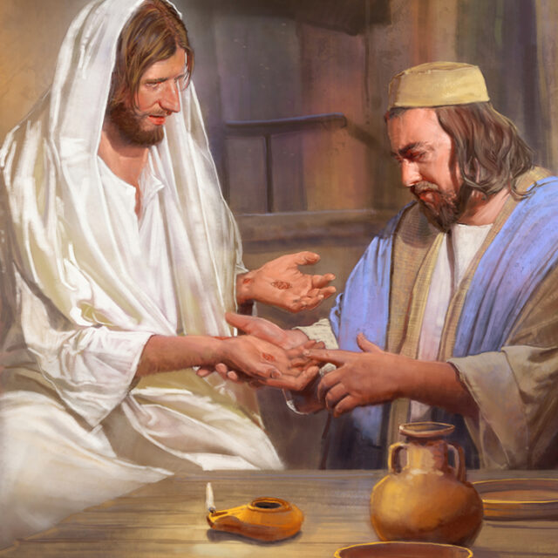

# **What is the cure for doubt?**

* Saying what God said will cure your doubts

# **What is the cure for unbelief?**

* The cure of unbelief is to find out what God said and make a decision to believe it

# **Abram started with doubt**

#### **Abram speaks out of the abundance of his heart**

##### Genesis 15:2-3

**2**And Abram said, Lord God, what wilt thou give me, seeing I go childless, and the steward of my house is this Eliezer of Damascus?

**3**And Abram said, Behold, to me thou hast given no seed: and, lo, one born in my house is mine heir.

# **God changed Abram’s name to Abraham**

#### **Abraham means the father of many nations**

Now everywhere Abraham goes – he hears people call him the Father of many nations

##### Romans 10:17

**17**So then faith cometh by hearing, and hearing by the word of God.

##### Genesis 17:1-8

**17**And when Abram was ninety years old and nine, the Lord appeared to Abram, and said unto him, I am the Almighty God; walk before me, and be thou perfect.

**2**And I will make my covenant between me and thee, and will multiply thee exceedingly.

**3**And Abram fell on his face: and God talked with him, saying,

**4**As for me, behold, my covenant is with thee, and thou shalt be a father of many nations.

**5**Neither shall thy name any more be called Abram, but thy name shall be Abraham; for a father of many nations have I made thee.

**6**And I will make thee exceeding fruitful, and I will make nations of thee, and kings shall come out of thee.

**7**And I will establish my covenant between me and thee and thy seed after thee in their generations for an everlasting covenant, to be a God unto thee, and to thy seed after thee.

**8**And I will give unto thee, and to thy seed after thee, the land wherein thou art a stranger, all the land of Canaan, for an everlasting possession; and I will be their God.

# **Abraham now believes**

##### **Abraham didn’t have to wait 25 years to believe – he could have believed at day #1 when he was 75.**

##### Romans 4:20-21

**20**He staggered not at the promise of God through unbelief; but was strong in faith, giving glory to God;

**21**And being fully persuaded that, what he had promised, he was able also to perform.

###### Once God changed his name, the promise child came in a year when he started using his faith.

##### Genesis 21:5

**5**And Abraham was an hundred years old, when his son Isaac was born unto him.

# **Jesus gives his disciples power to heal and cast unclean spirits**

##### Matthew 10:1

**10**And when he had called unto him his twelve disciples, he gave them power against unclean spirits, to cast them out, and to heal all manner of sickness and all manner of disease.

##### Luke 9:1-2

**9**Then he called his twelve disciples together, and gave them power and authority over all devils, and to cure diseases.

**2**And he sent them to preach the kingdom of God, and to heal the sick.

##### Luke 9:37-43

**37**And it came to pass, that on the next day, when they were come down from the hill, much people met him.

**38**And, behold, a man of the company cried out, saying, Master, I beseech thee, look upon my son: for he is mine only child.

**39**And, lo, a spirit taketh him, and he suddenly crieth out; and it teareth him that he foameth again, and bruising him hardly departeth from him.

**40**And I besought thy disciples to cast him out; and they could not.

**41**And Jesus answering said, O faithless and perverse generation, how long shall I be with you, and suffer you? Bring thy son hither.

**42**And as he was yet a coming, the devil threw him down, and tare him. And Jesus rebuked the unclean spirit, and healed the child, and delivered him again to his father.

**43**And they were all amazed at the mighty power of God…

# **The one who doubts is like a wave of the sea, blown and tossed by the wind**

##### James 1:5-8

**5 If any of you lacks wisdom, you should ask God, who gives generously to all without finding fault, and it will be given to you.**

**6 But when you ask, you must believe and not doubt, because the one who doubts is like a wave of the sea, blown and tossed by the wind.**

**7 That person should not expect to receive anything from the Lord.**

**8 Such a person is double-minded and unstable in all they do.**

# **The Tongue is a goal setter**

##### The Father and Jesus are our example

###### God calls things that are not as though they were

###### In Genesis: God saw darkness and called for light

##### Romans 4:17

**17**(As it is written, I have made thee a father of many nations,) before him whom he believed, even God, who quickeneth the dead, and calleth those things which be not as though they were.

##### Psalm 45:1

**45**My heart is inditing a good matter: I speak of the things which I have made touching the king: my tongue is the pen of a ready writer.

##### Proverbs 18:21

**21**Death and life are in the power of the tongue: and they that love it shall eat the fruit thereof.

Explain the cat and dog concept – calling things that are not as though they were.

If you say, I am taking the flu – you are calling for sickness.

If you say, I always run out of money this time of year – you are calling for lack.

If you say, I always make the wrong choice – you are calling for the opposite of wisdom