# Applied Faith – Part 1

# **Applied Faith #1**

#### **What kind of fruit is your tongue producing?**

###### Are you released words or faith or words of fear?

###### To Confess means to come into agreement with

Proverbs 18:21

**21**Death and life are in the power of the tongue: and they that love it shall eat the fruit thereof.

# **Faith works by love**

##### Rember what uncircumcised means – A stranger to the covenant of Promise

##### Galatians 5:6

**6**For in Jesus Christ neither circumcision availeth any thing, nor uncircumcision; but faith which worketh by love.

# **Everyday scriptures you should be Confessing: Establish yourself in God’s Love**

#### The Cross is at the Center – Cruciform Church of Christ

#### **Establish yourself in the love of God**

###### Confession: For God so loved me, that he gave his only begotten Son for me, that if I believe in him, I would not perish but have everlasting life.

John 3:16

16 For God so loved the world, that he gave his only begotten Son, that whosoever believeth in him should not perish, but have everlasting life.

# **Everyday scriptures you should be Confessing: Establish yourself in Love**

#### **Establish yourself in love**

###### Multiple languages without love does you no good

###### Praying in tongues without love, does you no good

###### A sounding brass or a tinkling cymbal at the wrong time really messes up the song

###### If you give “ALL” your good to the poor, without love it prophets nothing

###### Solomon level knowledge, without love – accomplishes nothing

###### Having faith to remove mountains – without love, means nothing

###### Even being a martyr – without love – prophets nothing

1 Corinthians 13: 1-3

**13**Though I speak with the tongues of men and of angels, and have not charity, I am become as sounding brass, or a tinkling cymbal.

**2**And though I have the gift of prophecy, and understand all mysteries, and all knowledge; and though I have all faith, so that I could remove mountains, and have not charity, I am nothing.

**3**And though I bestow all my goods to feed the poor, and though I give my body to be burned, and have not charity, it profiteth me nothing.

# **Everyday scriptures you should be Confessing: Establish yourself in Love**

#### **Characteristics of Love**

1 Corinthians 13: 4-7

###### Long suffering

###### Envies not

###### Vanteth not itself - to boast or brag about something

###### Doesn’t behave in a way that it not fit

###### Does not look for its own benefit

###### Not easily provoked – it has a long fuse

###### Is not puffed up – some similarities to the easter Island statues – (haughty means you act superior or look down on others) – Puffed up is a person who is proud and vain—who wants to make themselves appear or seem bigger and better than they are

###### Iniquity is immoral or grossly unfair behavior – [Loosed not the house of his prisoners]

###### Love rejoices in the truth

###### Bear all things – means to help carry a burden, or endure something

###### Love is never in unbelief

###### Love has a basis of hope – Hebrews 11:1

###### To endure all things is to remain in difficult situations for the sake of others

**4**Charity suffereth long, and is kind; charity envieth not; charity vaunteth not itself, is not puffed up,

**5**Doth not behave itself unseemly, seeketh not her own, is not easily provoked, thinketh no evil;

**6**Rejoiceth not in iniquity, but rejoiceth in the truth;

**7**Beareth all things, believeth all things, hopeth all things, endureth all things.

# **Everyday scriptures you should be Confessing: Establish yourself in Love**

#### Grace Baptist Church The Megalithic Crystalline Geopolymer ...

#### **Things other than love – will fail or vanish away**

Prophecies fail, tongues cease, knowledge vanishes (Noah’s Ark – Preflood world knowledge – megalithic stone structures)

Love never fails

1 Corinthians 13: 8-13

**8**Charity never faileth: but whether there be prophecies, they shall fail; whether there be tongues, they shall cease; whether there be knowledge, it shall vanish away.

**9**For we know in part, and we prophesy in part.

**10**But when that which is perfect is come, then that which is in part shall be done away.

**11**When I was a child, I spake as a child, I understood as a child, I thought as a child: but when I became a man, I put away childish things.

**12**For now we see through a glass, darkly; but then face to face: now I know in part; but then shall I know even as also I am known.

**13**And now abideth faith, hope, charity, these three; but the greatest of these is charity.

# **Everyday scriptures you should be confessing: Establish yourself in God’s Righteousness**

#### The Armor of God: Covered by His ...

#### **Establish yourself in righteousness – We wear the breast plate of righteousness**

###### Confession: I am the righteousness of God in Christ

##### 2 Corinthians 5:21

**21**For he hath made him to be sin for us, who knew no sin; that we might be made the righteousness of God in him.

# **Everyday scriptures you should be Confessing: Establish yourself in Prosperity**

#### Christian Inspiration! on X: "Psalm 1:2 ...

#### Psalm 1: 1-3 - Personalized

**1 I’m** Blessed because I don’t walk in the counsel of the ungodly, I don’t standeth in the way of sinners, and I don’t sit in the seat of the scornful.

**2**I delight in the law of the Lord; and in his law do I meditate day and night.

**3**I am like a tree planted by the rivers of water, I bring forth my fruit in his season; my leaf also does not wither; and whatsoever I do prospers.

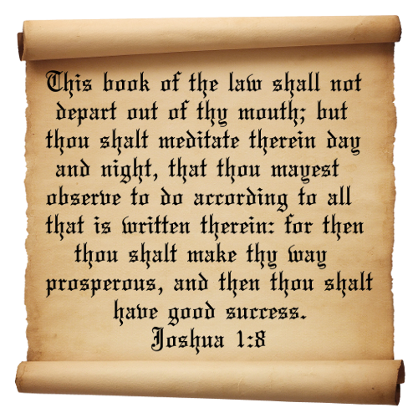

##### Joshua 1:8-9 – Personalized

**8**This book of the law does not depart out of my mouth; but I meditate therein day and night, that I may observe to do according to all that is written therein: for then I make thy way prosperous, and then I have good success.

**9**Because God commanded me to do so: I am strong and I have good courage; I am not afraid, I am not dismayed: for the Lord my God is with me wherever I go.

# **Everyday scriptures you should be confessing: Establish yourself Faith**

#### 

#### **Establish yourself in Faith**

###### Confession: I stagger not at the promise of God, through unbelief, but I am strong in faith, and I give glory to God, that what he has promised me in his word, he is also able to perform.

Romans 4:20

20 He staggered not at the promise of God through unbelief; but was strong in faith, giving glory to God;

# **Everyday scriptures you should be Confessing: Protection**

##### Forged In Fire: Bladesgiving | The ...

##### Isaiah 54:17 Personalized

**17**No weapon that is formed against me will prosper; and every tongue that shall rise against me in judgment thou shalt condemn. This is the heritage of the servants of the Lord, and their righteousness is of me, saith the Lord.

# **Everyday scriptures you should be Confessing: Protection**

#### 

#### **Speak Protection over yourself**

##### Psalm 91 Personalized

**91**I dwelleth in the secret place of the most High and I abide under the shadow of the Almighty.

**2**I say of the Lord, He is my refuge and my fortress: my God; in him do I trust.

**3**Surely he shall delivers me from the snare of the fowler, and from the noisome pestilence.

**4**He covers me with his feathers, and under his wings do I trust: his truth is my shield and buckler.

**5**I am not be afraid for the terror by night; nor for the arrow that flieth by day;

**6**Nor for the pestilence that walketh in darkness; nor for the destruction that wasteth at noonday.

**7**A thousand shall fall at my side, and ten thousand at my right hand; but it shall not come near me.

**8**Only with my eyes shalt thou behold and see the reward of the wicked.

**9**Because I have made the Lord, which is my refuge, even the most High, my habitation;

**10**There shall no evil befall me, neither shall any plague come nigh my dwelling.

**11**For he shall give his angels charge over me, to keep me in all thy ways.

**12**They shall bear me up in their hands, lest I dash thy foot against a stone.

**13**I tread upon the lion and adder: the young lion and the dragon I trample under feet.

**14**Because I hath set my love upon him, therefore he delivers me: He sets me on high, because I hath known his name.

**15** I call upon him, and he will answers me: He is with me in trouble; he delivers me, and honor’s me.

**16**With long life he satisfies me, and I show him my salvation.

##### 3 John 2

**2**Beloved, I wish above all things that thou mayest prosper and be in health, even as thy soul prospereth.

# **Everyday scriptures you should be Confessing: Peace and Safety**

##### Psalm 23

**23**The Lord is my shepherd; I shall not want.

**2**He maketh me to lie down in green pastures: he leadeth me beside the still waters.

**3**He restoreth my soul: he leadeth me in the paths of righteousness for his name's sake.

**4**Yea, though I walk through the valley of the shadow of death, I will fear no evil: for thou art with me; thy rod and thy staff they comfort me.

**5**Thou preparest a table before me in the presence of mine enemies: thou anointest my head with oil; my cup runneth over.

**6**Surely goodness and mercy shall follow me all the days of my life: and I will dwell in the house of the Lord for ever.

# **Everyday scriptures you should be Confessing: Freedom from fear**

*Isaiah 54:14*

14 In righteousness shalt thou be established: thou shalt be far from oppression; for thou shalt not fear: and from terror; for it shall not come near thee.

##### 2 Timothy 1:7

**7**For God hath not given us the spirit of fear; but of power, and of love, and of a sound mind.

# **Everyday scriptures you should be confessing: Hearing the voice of God**

#### Raising Sheep ...

#### John 10:27-28

**27**My sheep hear my voice, and I know them, and they follow me:

**28**And I give unto them eternal life; and they shall never perish, neither shall any man pluck them out of my hand.

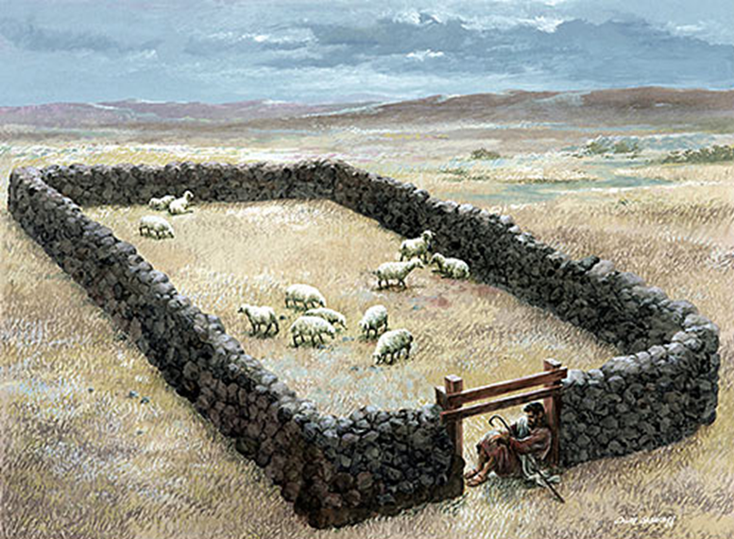

#### John 10:1-5

**Verily, verily, I say unto you, He that entereth not by the door into the sheepfold, but climbeth up some other way, the same is a thief and a robber.**

**2But he that entereth in by the door is the shepherd of the sheep.**

**3To him the porter openeth; and the sheep hear his voice: and he calleth his own sheep by name, and leadeth them out.**

**4And when he putteth forth his own sheep, he goeth before them, and the sheep follow him: for they know his voice.**

**5And a stranger will they not follow, but will flee from him: for they know not the voice of strangers.**

# **Everyday scriptures you should be confessing: Growing your Faith**

#### Frontier Co-op Yellow Mustard Seed, Whole 1 lb. | Frontier Co-op

#### **A mustard seed is very small – but when it grows up, it overshadows all that is around**

##### Matthew 17:20-21

And Jesus said unto them, Because of your unbelief: for verily I say unto you, If ye have faith as a grain of mustard seed, ye shall say unto this mountain, Remove hence to yonder place; and it shall remove; and nothing shall be impossible unto you.

##### Luke 17:5-6

**5**And the apostles said unto the Lord, Increase our faith.

**6**And the Lord said, If ye had faith as a grain of mustard seed, ye might say unto this sycamine tree, Be thou plucked up by the root, and be thou planted in the sea; and it should obey you.

# **Confessions based on Mark 11:23**

I am always in the right place at the right time