# Applied Faith – Part 2

The more you know – the more you can do

# **The more you know**

In all areas of life knowledge plays an important role. Those who know the stock market can trade and buy shares to turn a profit. Those who know geometry and calculus can tell you where a stone-throw from a sling with land or put the space shuttle on the moon. Those who know 3D have the ability to communicate complex visual models on nearly infinite rotation vectors and share their ideas with others.

In the natural world – the more you know, the more you can do.

The same is true in the spiritual world. The anti-Christ will understand dark sentences – and he will be able to perform evil on a level well above everyone else previously (speculation: with the exception perhaps of some of the fallen angels).

When you know how to use your faith, you can take spiritual energy from God and a withered hand will be restored.

Did Jesus need to walk on the water? Well, you could argue that he had to get to a meeting on the other side, or that people needed deliverance in a timely manner. He could have walked around the sea, or taken a chariot, rode a horse, went in a boat…there were many possibilities. However, faith says that all things are possible to him that believes – Mark 9:23. Faith said that the water was not an impediment to where Jesus needed to go. Faith said that you can step above modern transportation to accomplish what you needed to accomplish.

Don’t limit God – and don’t limit the faith he gave us to use.

#### **Faith is meant to be used all the time to correct, change, or supply what is needed or desired in the natural world**

I trow not – (this is another statement, like verily I say unto you – meaning truly, or “I’m not kidding guys, this is the real thing”)

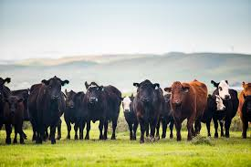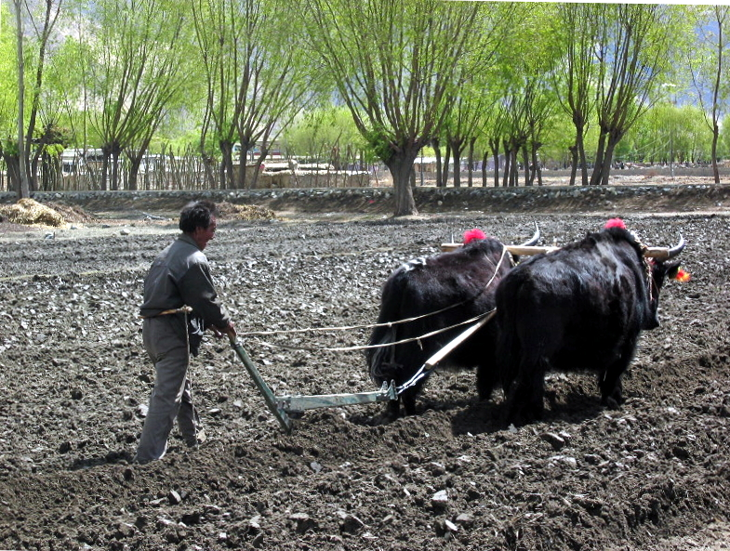

##### Matthew 14:17-19

**7**But which of you, having a servant plowing or feeding cattle, will say unto him by and by, when he is come from the field, Go and sit down to meat?

**8**And will not rather say unto him, Make ready wherewith I may sup, and gird thyself, and serve me, till I have eaten and drunken; and afterward thou shalt eat and drink?

**9**Doth he thank that servant because he did the things that were commanded him? I trow not.

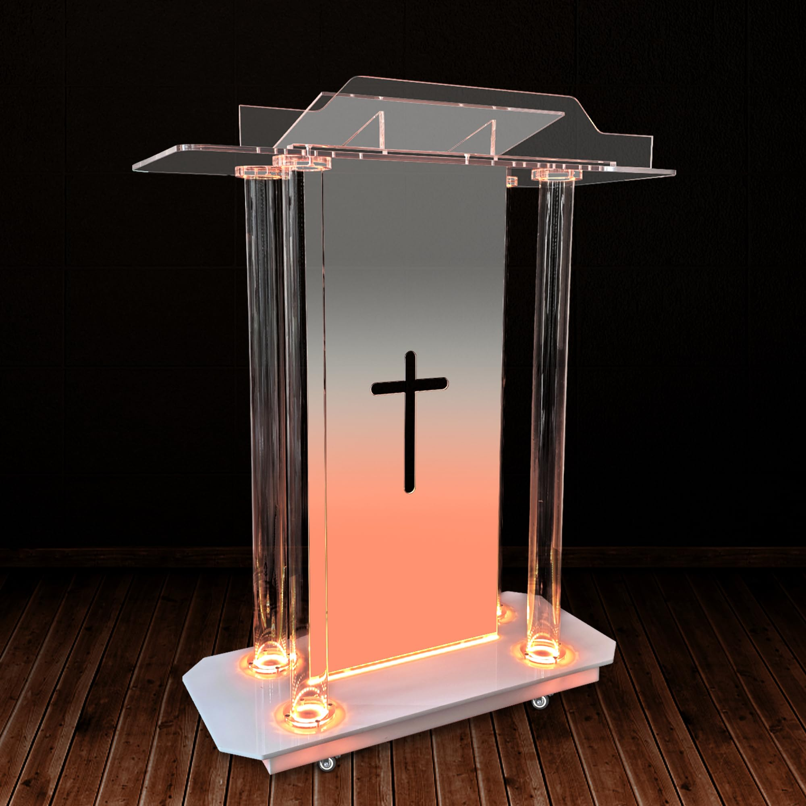

#### **Your faith will never rise above the level of Word that you receive.**

**14**How then shall they call on him in whom they have not believed? and how shall they believe in him of whom they have not heard? and how shall they hear without a preacher?

**17**So then faith cometh by hearing, and hearing by the word of God.

#### **If you believe on Jesus, you will do the works he did and greater works than him also**

**12**Verily, verily, I say unto you, He that believeth on me, the works that I do shall he do also; and greater works than these shall he do; because I go unto my Father.

Often times we hear or read about the miracles that Jesus did, we don’t stop to acknowledge and identify the very nature of what they were.

# **Matter Replication**

#### Multiplication of Loaves a Miracle or Just a Lesson in Sharing? – Defenders of the Catholic Faith

#### **Jesus replicated more loaves and fish with his words**

##### Matthew 14:17-19

**17**And they say unto him, We have here but five loaves, and two fishes.

**18**He said, Bring them hither to me.

**19**And he commanded the multitude to sit down on the grass, and took the five loaves, and the two fishes, and looking up to heaven, he blessed, and brake, and gave the loaves to his disciples, and the disciples to the multitude.

#### **A second time Jesus Replicates matter with his words**

##### Matthew 15:29-39

**33**And his disciples say unto him, Whence should we have so much bread in the wilderness, as to fill so great a multitude?

**34**And Jesus saith unto them, How many loaves have ye? And they said, Seven, and a few little fishes.

**35**And he commanded the multitude to sit down on the ground.

**36**And he took the seven loaves and the fishes, and gave thanks, and brake them, and gave to his disciples, and the disciples to the multitude.

**37**And they did all eat, and were filled: and they took up of the broken meat that was left seven baskets full.

**38**And they that did eat were four thousand men, beside women and children.

# **Matter Transformation – Water into wine**

##### 10+ Jesus Turns Water Into Wine Stock Photos, Pictures & Royalty-Free Images - iStock

##### **Jesus transforms one kind of matter into another kind**

###### This is the best sermon – whatever he says, do it!

##### John 2:1-5

**2**And the third day there was a marriage in Cana of Galilee; and the mother of Jesus was there:

**2**And both Jesus was called, and his disciples, to the marriage.

**3**And when they wanted wine, the mother of Jesus saith unto him, They have no wine.

**4**Jesus saith unto her, Woman, what have I to do with thee? mine hour is not yet come.

**5**His mother saith unto the servants, Whatsoever he saith unto you, do it.

# **Matter Transformation – Water into wine**

##### John 2:6-11

**6**And there were set there six waterpots of stone, after the manner of the purifying of the Jews, containing two or three firkins apiece.

**7**Jesus saith unto them, Fill the waterpots with water. And they filled them up to the brim.

**8**And he saith unto them, Draw out now, and bear unto the governor of the feast. And they bare it.

**9**When the ruler of the feast had tasted the water that was made wine, and knew not whence it was: (but the servants which drew the water knew;) the governor of the feast called the bridegroom,

**10**And saith unto him, Every man at the beginning doth set forth good wine; and when men have well drunk, then that which is worse: but thou hast kept the good wine until now.

# **Matter Transformation – Stone into bread**

#### **When is the last time you were hungry and you turned a stone into bread using your faith?**

###### If there wasn’t a last time, why not?

#### Stone | Palworld Wiki | Fandom130,200+ Red Arrow Stock Photos ...Small Loaf French Bread Recipe - One ...

#### **If this wasn’t a full capability of Jesus, it would not have been a temptation**

###### Jesus could have turned the stone into bread – its no different than water into wine

Matthew 4:3

**3**And when the tempter came to him, he said, If thou be the Son of God, command that these stones be made bread.

# **Cursing the Fig Tree – Another perspective**

#### The magic of tropical forests and the fig trees that live in them | Under The BanyanOrmiston fig tree dead: Removal of historic tree brings back memories | The Courier Mail

#### Free Green Cedar - free stuff - craigslistBest Firewood Northern Ireland: Cedarwood Fuels

#### **Jesus taught us how to change green wood into dry wood**

###### Perhaps only a previous firewood yard owner could appreciate this in this way, but, what if you were cold, and only had green wood?

Matthew 21:18-19

**18**Now in the morning as he returned into the city, he hungered.

**19**And when he saw a fig tree in the way, he came to it, and found nothing thereon, but leaves only, and said unto it, Let no fruit grow on thee henceforward for ever. And presently the fig tree withered away.

# **The blind see – Another type of matter transformation / creation**

#### Jesus Heals the Blind Man | Sight Restored by Faith | Gospel Art

#### **Whether it be broken blood vessels in the eyes that were restored, or core elements of physical organs that were missing or needed to be fixed or replaced – matter came into existence or was modified so the blind man could see again**

Matthew 21:18-19

###### According to your faith – be it unto you. Instead of Jesus saying, “Eyes” see, he releases his faith in a unique way, where we takes his faith, uses it to discern what they have been believe (according to your faith), and then manifests that healing in there eyes. This is an extremely unique way of doing things. With the woman who had the issue of blood – Jesus didn’t use his faith, (other than being the author and the finisher), he said, daughter, be of good comfort, thy faith hath made thee whole, he simply said your faith worked.

27 And when Jesus departed thence, two blind men followed him, crying, and saying, Thou son of David, have mercy on us.

28 And when he was come into the house, the blind men came to him: and Jesus saith unto them, Believe ye that I am able to do this? They said unto him, Yea, Lord.

29 Then touched he their eyes, saying, According to your faith be it unto you.

30 And their eyes were opened; and Jesus straitly charged them, saying, See that no man know it.

# **Teleportation**

#### WHEN JESUS IS OUTSIDE THE BOAT!. Text ... Bible Fun For Kids: 4.13. The Great Catch of Fish & Breakfast With Jesus

#### **Jesus, the boat, and the disciples were teleported to the land on the other side of the water**

John 6:18-21

**18**And the sea arose by reason of a great wind that blew.

**19**So when they had rowed about five and twenty or thirty furlongs, they see Jesus walking on the sea, and drawing nigh unto the ship: and they were afraid.

**20**But he saith unto them, It is I; be not afraid.

**21**Then they willingly received him into the ship: and immediately the ship was at the land whither they went.

# **Something akin to a cloak of invisibility – not specifically but maybe**

#### PAUSE AND PRAY: DEALING WITH REJECTIONS (Luke 4:24-30) | Reflection by Sis. Eda Castillo. #KatolikongPinoy | Facebook

#### In this scenario we are not actually told what happened – but he passed to the midst of the mob without them being able to touch him. Etherealness, mass confusion, invisibility – we don’t know, but we know that it happed. Check out Luke 4:29 - 30 account as well.

#### **JOHN 10:30-39**

**30**I and my Father are one.

**31**Then the Jews took up stones again to stone him.

**32**Jesus answered them, Many good works have I shewed you from my Father; for which of those works do ye stone me?

**33**The Jews answered him, saying, For a good work we stone thee not; but for blasphemy; and because that thou, being a man, makest thyself God.

**34**Jesus answered them, Is it not written in your law, I said, Ye are gods?

**35**If he called them gods, unto whom the word of God came, and the scripture cannot be broken;

**36**Say ye of him, whom the Father hath sanctified, and sent into the world, Thou blasphemest; because I said, I am the Son of God?

**37**If I do not the works of my Father, believe me not.

**38**But if I do, though ye believe not me, believe the works: that ye may know, and believe, that the Father is in me, and I in him.

**39**Therefore they sought again to take him: but he escaped out of their hand,

#### **Luke 4:29-30**

**29**And rose up, and thrust him out of the city, and led him unto the brow of the hill whereon their city was built, that they might cast him down headlong.

**30**But he passing through the midst of them went his way,