# Applied Faith

### Part 3

The Hall of Faith

As we walk through the hall of faith and see posters on the left & right walls of the elders, Abel, Enoch, Noah, Abraham, Sara, Isaac, Joseph, Moses, Rahab, Gideon, Barak, Samson, Jephthae, David, Samuel and the prophets.

# **Point #1: The Hall of Faith**

#### **Obtaining a good report**

###### The Elders obtained a good report by Faith

##### Hebrews 11:1-2

**11**Now faith is the substance of things hoped for, the evidence of things not seen.

**2**For by it the elders obtained a good report.

#### **The Worlds were framed by the Word of God**

###### Things that were made – were not made of things that appear

When you are using your Faith to believe God for an answer to prayer, we cannot based our progress in receiving on physical circumstances. Faith cannot be seen with the natural eyes.

##### Hebrews 11:3

**3**Through faith we understand that the worlds were framed by the word of God, so that things which are seen were not made of things which do appear.

#### **By Faith Abel Offered a more excellent sacrifice**

###### Even in death, his testimony still speaks

##### Hebrews 11:4

4 By faith Abel offered unto God a more excellent sacrifice than Cain, by which he obtained witness that he was righteous, God testifying of his gifts: and by it he being dead yet speaketh.

#### **Enoch was Translated that he should not see death**

###### He walked with God for 365 years

###### There are two types of translation – one from A to B and one from Earth to Heaven

###### Having a testimony that he pleased God – means that he had a life style of Faith – without faith it is impossible to please God

###### Enoch was translated so that “He would not see death” – which means there is a purpose in it. It is appointed unto men to die once – Hebrews 9:27

##### Hebrews 11:5

5By faith Enoch was translated that he should not see death; and was not found, because God had translated him: for before his translation he had this testimony, that he pleased God.

Genesis 5:24

**24**And Enoch walked with God: and he was not; for God took him.

#### **Faith is required to please God**

###### You must come to God and believe that he is

###### You must also believe that he is a rewarder of them that diligently seek him

###### Faith is required in both areas – some folks leave the second one out

##### Hebrews 11:6

**6** But without faith it is impossible to please him: for he that cometh to God must believe that he is, and that he is a rewarder of them that diligently seek him.

#### **By Faith Noah prepared an Ark to the saving of his house**

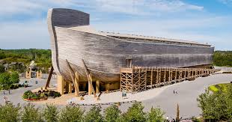

###### He was warned of God of things not seen as yet

###### He became an heir of the righteousness which is by faith

###### Rain had not existed on the earth – they didn’t know what it was

###### The whole town probably laughed at him.

##### Hebrews 11:7

**7**By faith Noah, being warned of God of things not seen as yet, moved with fear, prepared an ark to the saving of his house; by the which he condemned the world, and became heir of the righteousness which is by faith.

#### **Based on Faith alone, Abraham went out of his own country to a unknown location**

###### He looked for a city which had foundations, whose builder and maker is God

###### No forwarding address

###### No way to plan

###### Searching for a city whose builder and maker is God – that’s quite a quest

#### Hebrews 11:8-9

8 By faith Abraham, when he was called to go out into a place which he should after receive for an inheritance, obeyed; and he went out, not knowing whither he went.

9 By faith he sojourned in the land of promise, as in a strange country, dwelling in tabernacles with Isaac and Jacob, the heirs with him of the same promise:

10 For he looked for a city which hath foundations, whose builder and maker is God.

#### **Sarah received strength to conceive seed when she was old**

###### He looked for a city which had foundations, whose builder and maker is God

###### God renewed the youth of Abraham and Sarah so they could conceive.

#### Hebrews 11:8-9

**11**Through faith also Sara herself received strength to conceive seed, and was delivered of a child when she was past age, because she judged him faithful who had promised.

**12**Therefore sprang there even of one, and him as good as dead, so many as the stars of the sky in multitude, and as the sand which is by the sea shore innumerable.

#### **Abraham believed God for Isaac**

###### Abram did not – until God changed this name to mean the Father of many nations

###### Abraham staggered not at the promise of God through unbelief

###### He considered not his own body, now dead, nor the deadness of Sarah’s womb

#### Romans 4:10-22

**13**For the promise, that he should be the heir of the world, was not to Abraham, or to his seed, through the law, but through the righteousness of faith.

**14**For if they which are of the law be heirs, faith is made void, and the promise made of none effect:

**15**Because the law worketh wrath: for where no law is, there is no transgression.

**16**Therefore it is of faith, that it might be by grace; to the end the promise might be sure to all the seed; not to that only which is of the law, but to that also which is of the faith of Abraham; who is the father of us all,

**17**(As it is written, I have made thee a father of many nations,) before him whom he believed, even God, who quickeneth the dead, and calleth those things which be not as though they were.

**18**Who against hope believed in hope, that he might become the father of many nations, according to that which was spoken, So shall thy seed be.

**19**And being not weak in faith, he considered not his own body now dead, when he was about an hundred years old, neither yet the deadness of Sarah's womb:

**20**He staggered not at the promise of God through unbelief; but was strong in faith, giving glory to God;

**21**And being fully persuaded that, what he had promised, he was able also to perform.

**22**And therefore it was imputed to him for righteousness.

#### **They now desire a better country (a heavenly one)**

###### They were strangers and pilgrims on earth

###### God is not ashamed to becalled their God

#### Hebrews 11:13-16

**13**These all died in faith, not having received the promises, but having seen them afar off, and were persuaded of them, and embraced them, and confessed that they were strangers and pilgrims on the earth.

**14**For they that say such things declare plainly that they seek a country.

**15**And truly, if they had been mindful of that country from whence they came out, they might have had opportunity to have returned.

**16**But now they desire a better country, that is, an heavenly: wherefore God is not ashamed to be called their God: for he hath prepared for them a city.

#### **Abraham was willing to offer up Isaac, which gave God the right to offer his son**

###### God gave Abraham a vision of Isaac being raised from the dead

#### Hebrews 11:17-19

17 By faith Abraham, when he was tried, offered up Isaac: and he that had received the promises offered up his only begotten son,

18 Of whom it was said, That in Isaac shall thy seed be called:

19 Accounting that God was able to raise him up, even from the dead; from whence also he received him in a figure.

#### **Jacob & Esau were blessed by Faith from Isaac concerning things to come**

#### Hebrews 11:20

**20**By faith Isaac blessed Jacob and Esau concerning things to come.

#### **The sons of Joseph were blessed by the faith of Jacob in a similar way**

Blessing must be delivered by faith

#### Hebrews 11:21

21 By faith Jacob, when he was a dying, blessed both the sons of Joseph; and worshipped, leaning upon the top of his staff.

#### **Joseph gives a commandment concerning his bones**

#### Hebrews 11:22

**22**By faith Joseph, when he died, made mention of the departing of the children of Israel; and gave commandment concerning his bones.

#### **By Faith Moses’s parent hid him**

#### Hebrews 11:23

23 By faith Moses, when he was born, was hid three months of his parents, because they saw he was a proper child; and they were not afraid of the king's commandment.

#### **By Faith Moses refused to be called the son of Pharaoh’s daughter**

###### Being right with God was more important than sin for a season – [See correlation music]

#### Hebrews 11:24-26

**24**By faith Moses, when he was come to years, refused to be called the son of Pharaoh's daughter;

**25**Choosing rather to suffer affliction with the people of God, than to enjoy the pleasures of sin for a season;

**26**Esteeming the reproach of Christ greater riches than the treasures in Egypt: for he had respect unto the recompence of the reward.

#### **By Faith Moses forsakes Egypt**

###### Moses chooses not to fear the wrath of the King

#### Hebrews 11:27

**27**By faith he forsook Egypt, not fearing the wrath of the king: for he endured, as seeing him who is invisible.

#### **Through Faith Moses keeps the passover**

###### & the sprinkling of blood

#### Hebrews 11:24-28

28 Through faith he kept the passover, and the sprinkling of blood, lest he that destroyed the firstborn should touch them.

#### **By Faith Moses leads the children of Israel through the red sea**

###### (which the Egyptians assaying to do – were drowned)

#### Reference verse: Proverbs 26:27

**27**Whoso diggeth a pit shall fall therein: and he that rolleth a stone, it will return upon him.

#### Hebrews 11:29

Through faith he kept the passover, and the sprinkling of blood, lest he that destroyed the firstborn should touch them.

#### **By Faith the Walls of Jericho fell down**

###### For 6 days they walked around Jericho and nothing happened

###### The 7th day, that had to walk around it 7 times.

###### This is an act of faith much like letting the guy down through the roof

###### (after 7 days)

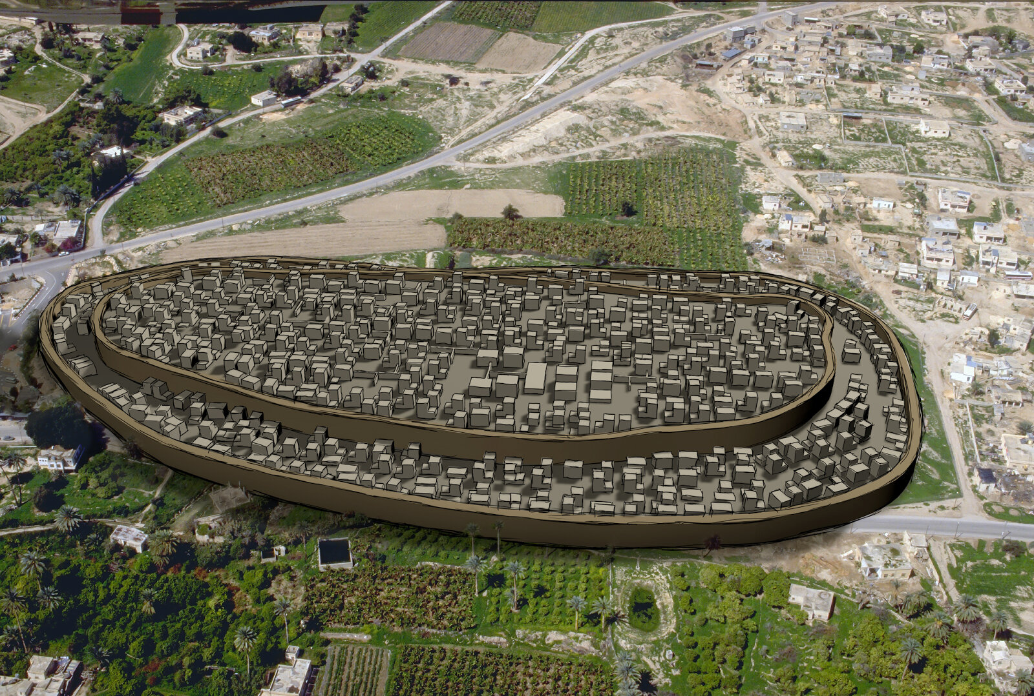

#### Hebrews 11:30

**30**By faith the walls of Jericho fell down, after they were compassed about seven days.

#### **God pay’s attention to red cords**

###### Its more important to God what you believe, then what your past is

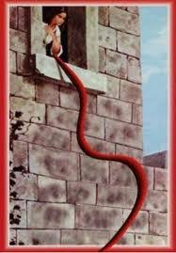

#### Hebrews 11:31

31 By faith the harlot Rahab perished not with them that believed not, when she had received the spies with peace.

#### **By Faith – Kingdoms were subdued, righteousness was wrought & the Mouths of Lions were stopped**

###### Some chosen a better resurrection over deliverance

###### Note that deliverance could have been chosen – you don’t have to suffer

#### Hebrews 11:32 - 40

**32**And what shall I more say? for the time would fail me to tell of Gedeon, and of Barak, and of Samson, and of Jephthae; of David also, and Samuel, and of the prophets:

**33**Who through faith subdued kingdoms, wrought righteousness, obtained promises, stopped the mouths of lions.

**34**Quenched the violence of fire, escaped the edge of the sword, out of weakness were made strong, waxed valiant in fight, turned to flight the armies of the aliens.

**35**Women received their dead raised to life again: and others were tortured, not accepting deliverance; that they might obtain a better resurrection:

**36**And others had trial of cruel mockings and scourgings, yea, moreover of bonds and imprisonment:

**37**They were stoned, they were sawn asunder, were tempted, were slain with the sword: they wandered about in sheepskins and goatskins; being destitute, afflicted, tormented;

**38**(Of whom the world was not worthy:) they wandered in deserts, and in mountains, and in dens and caves of the earth.

**39**And these all, having obtained a good report through faith, received not the promise:

**40**God having provided some better thing for us, that they without us should not be made perfect.

# **Summary**

Faith always speaks the desired end-result

Faith does not take into account the circumstances in the natural

Faith gives substance in the natural, to unseen things in the supernatural

Faith calls things that are not as though they were

Faith without works is dead

Faith requires action – (As they went, they were healed)

#### **The just shall live by faith**

Make sure God has pleasure in you

**38**Now the just shall live by faith: but if any man draw back, my soul shall have no pleasure in him.

# **Correlating Music**

**Sin for a season – Steve Taylor**

<https://www.youtube.com/watch?v=shKzwYWabCk>

The voice of Truth – Casting Crowns

<https://www.youtube.com/watch?v=9cKm_mYVPQE>