**Heaven – Part 1**

**John 3:16**

**16For God so loved the world, that he gave his only begotten Son, that whosoever believeth in him should not perish, but have everlasting life.**

# **So shall we ever be with the Lord**

**The Lord will strengthen**

##### 1 Thessalonians 4:16-17

**16**For the Lord himself shall descend from heaven with a shout, with the voice of the archangel, and with the trump of God: and the dead in Christ shall rise first:

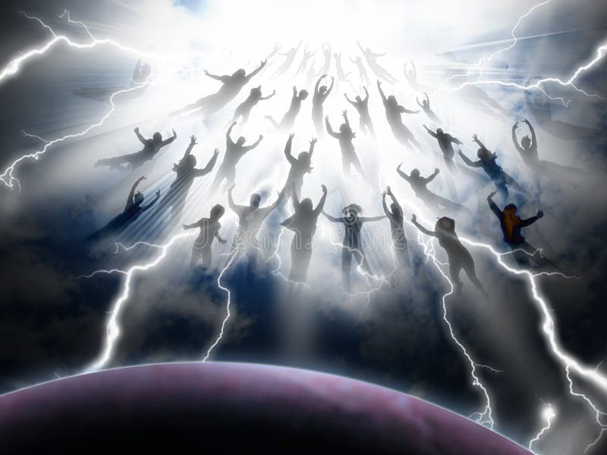

**17**Then we which are alive and remain shall be caught up together with them in the clouds, to meet the Lord in the air: and so shall we ever be with the Lord.

# **Our desire is for God**

#### Psalm 73:25

**25**Whom have I in heaven but thee? and there is none upon earth that I desire beside thee.

##### Colossians 3:2

**2**Set your affection on things above, not on things on the earth.

 

##### Matthew 6:19-20

**19**Lay not up for yourselves treasures upon earth, where moth and rust doth corrupt, and where thieves break through and steal:

**20**But lay up for yourselves treasures in heaven, where neither moth nor rust doth corrupt, and where thieves do not break through nor steal:

#### **There aren’t 7 other choices out there**

#### Deuteronomy 4:39

**39**Know therefore this day, and consider it in thine heart, that the Lord he is God in heaven above, and upon the earth beneath: there is none else.

##### 2 Corinthians 5:1

**5**For we know that if our earthly house of this tabernacle were dissolved, we have a building of God, an house not made with hands, eternal in the heavens.

# **Jesus Ascends into Heaven**

#### Mark 16:19

**19**So then after the Lord had spoken unto them, he was received up into heaven, and sat on the right hand of God.

#### Acts 1:10-11

**10**And while they looked stedfastly toward heaven as he went up, behold, two men stood by them in white apparel;

**11**Which also said, Ye men of Galilee, why stand ye gazing up into heaven? this same Jesus, which is taken up from you into heaven, shall so come in like manner as ye have seen him go into heaven.

# **Where is Heaven?**

# **How long will we be in Heaven?**

##### Daniel 7:25

**25**And he shall speak great words against the most High, and shall wear out the saints of the most High, and think to change times and laws: and they shall be given into his hand until a time and times and the dividing of time.

# **What is heaven like?**

##### John 14:2

**2**In my Father's house are many mansions: if it were not so, I would have told you. I go to prepare a place for you.

# **Did Old Testament saints go to heaven?**

##### Luke 16:19-31

**26**And beside all this, between us and you there is a great gulf fixed: so that they which would pass from hence to you cannot; neither can they pass to us, that would come from thence.

#### **The Thief on the Cross – Shortest stay in Paradise**

##### Luke 23:43

**43**And Jesus said unto him, Verily I say unto thee, Today shalt thou be with me in paradise.

# **Who is in heaven now?**

Enoch, Elijah, Jesus, The Father, Old Testament Saints, those who have died since Jesus rose and confessed him as Lord.

##### Genesis 5:24

**24**And Enoch walked with God: and he was not; for God took him.

##### 2 Kings 2:11-12

**11**And it came to pass, as they still went on, and talked, that, behold, there appeared a chariot of fire, and horses of fire, and parted them both asunder; and Elijah went up by a whirlwind into heaven.

**12**And Elisha saw it, and he cried, My father, my father, the chariot of Israel, and the horsemen thereof. And he saw him no more: and he took hold of his own clothes, and rent them in two pieces.

##### Acts 1:9-11

**9**And when he had spoken these things, while they beheld, he was taken up; and a cloud received him out of their sight.

**10**And while they looked stedfastly toward heaven as he went up, behold, two men stood by them in white apparel;

**11**Which also said, Ye men of Galilee, why stand ye gazing up into heaven? this same Jesus, which is taken up from you into heaven, shall so come in like manner as ye have seen him go into heaven.

##### 2 Corinthians 5:8

**8**We are confident, I say, and willing rather to be absent from the body, and to be present with the Lord.

##### Romans 10:9-10

**9**That if thou shalt confess with thy mouth the Lord Jesus, and shalt believe in thine heart that God hath raised him from the dead, thou shalt be saved.

**10**For with the heart man believeth unto righteousness; and with the mouth confession is made unto salvation.

# **What are the thoughts of those in heaven now towards us?**

#### Luke 15:7

**7**I say unto you, that likewise joy shall be in heaven over one sinner that repenteth, more than over ninety and nine just persons, which need no repentance.

# **What will the new heaven and earth be like?**

##### Revelation 21:4

**4**And God shall wipe away all tears from their eyes; and there shall be no more death, neither sorrow, nor crying, neither shall there be any more pain: for the former things are passed away.

#### Revelation 21:22-27

**22**And I saw no temple therein: for the Lord God Almighty and the Lamb are the temple of it.

**23**And the city had no need of the sun, neither of the moon, to shine in it: for the glory of God did lighten it, and the Lamb is the light thereof.

**24**And the nations of them which are saved shall walk in the light of it: and the kings of the earth do bring their glory and honour into it.

**25**And the gates of it shall not be shut at all by day: for there shall be no night there.

**26**And they shall bring the glory and honour of the nations into it.

**27**And there shall in no wise enter into it any thing that defileth, neither whatsoever worketh abomination, or maketh a lie: but they which are written in the Lamb's book of life.

#### Revelation 21:21

**21**And the twelve gates were twelve pearls: every several gate was of one pearl: and the street of the city was pure gold, as it were transparent glass.



#### Revelation 22:1-5

**22**And he shewed me a pure river of water of life, clear as crystal, proceeding out of the throne of God and of the Lamb.

**2**In the midst of the street of it, and on either side of the river, was there the tree of life, which bare twelve manner of fruits, and yielded her fruit every month: and the leaves of the tree were for the healing of the nations.

**3**And there shall be no more curse: but the throne of God and of the Lamb shall be in it; and his servants shall serve him:

**4**And they shall see his face; and his name shall be in their foreheads.

**5**And there shall be no night there; and they need no candle, neither light of the sun; for the Lord God giveth them light: and they shall reign for ever and ever.